**AIM:TO PERFORM BANKING OPERATIONS USING PROCEDURES**

CREATE TABLE ACC(AC_NO NUMBER(5),NAME VARCHAR(20),BALANCE NUMBER(6));

INSERT INTO ACC VALUES(:AC_NO,:NAME,:BALANCE);

SELECT * FROM ACC;

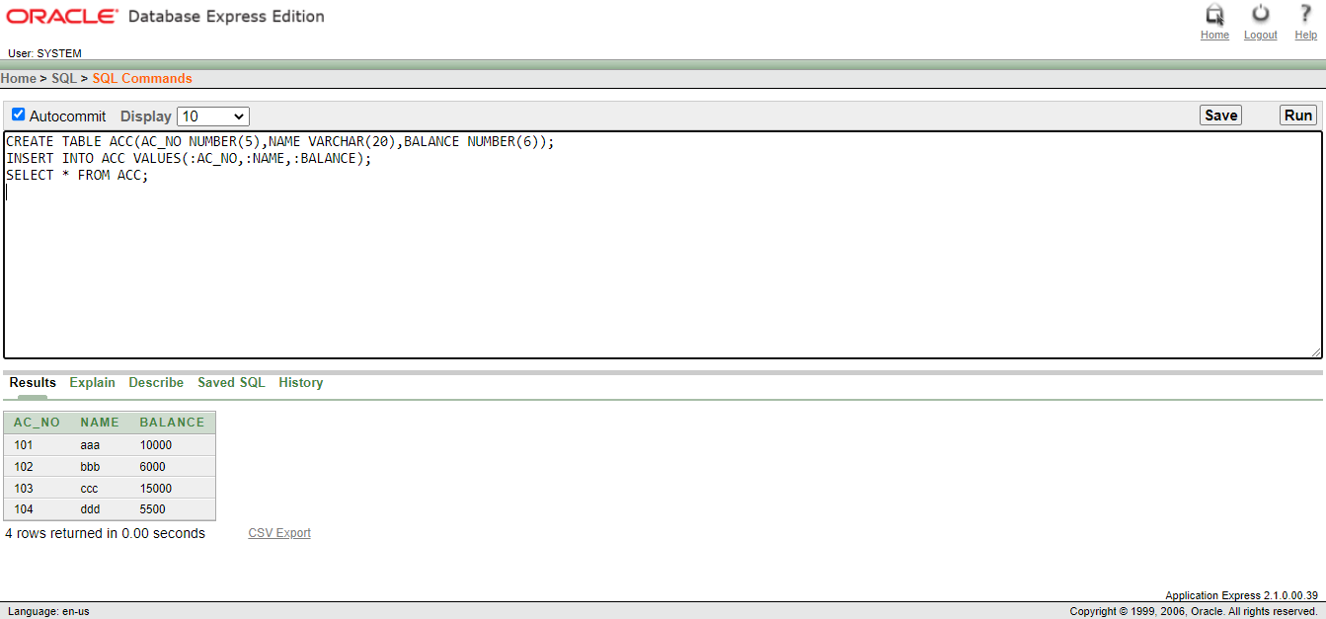

CREATE OR REPLACE PROCEDURE WITHDRAW(AC_NO1 IN NUMBER,AMOUNT1 IN NUMBER) IS

BEGIN

UPDATE ACC SET BALANCE=BALANCE-AMOUNT1 WHERE AC_NO=AC_NO1;

END;

CREATE OR REPLACE PROCEDURE DEPOSIT(AC_NO1 IN NUMBER,AMOUNT1 IN NUMBER) IS

BEGIN

UPDATE ACC SET BALANCE=BALANCE+AMOUNT1 WHERE

AC_NO=AC_NO1;

END;

DECLARE

CHOICE NUMBER;

AC_NO1 NUMBER(5);

AMOUNT NUMBER(5);

BEGIN

AC_NO1:=:AC_NO1;

CHOICE:=:CHOICE;

AMOUNT:=:AMOUNT;

IF

CHOICE=1 THEN DEPOSIT(AC_NO1,AMOUNT);

ELSE

WITHDRAW(AC_NO1,AMOUNT);

END IF;

END;

SELECT * FROM ACC;

